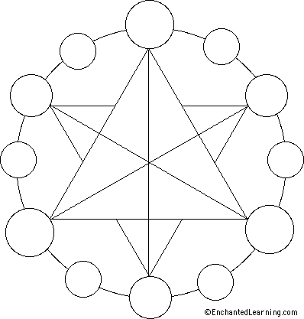
C O L O R

Color depends on light, because it is made of light.
There must be light for us to see color
The whiter the light, the more true the colors will be.

- You may choose to use these blank color wheel s and hand color or use find your own
- Google; your theme and color wheels
- Insert or customize theme images…be creative , you can change the suggested layout

Use words below as labels for custom color wheels

HUE another word for color

PRIMARY Triad red yellow blue

SECONDARY Triad orange green violet

INTERMEDIATE primary mixed with a secondary

ANALOGOUS 3 hues next to each other on the color wheel

WARM COLOR DOMINANCE

COOL COLOR DOMINANCE

MONOCROMATIC different values of one hue

COMPLEMENTARYcolors opposite on the color wheel

NEUTRAL COLORS (not warm or cool) brown – gray- white – blac

