Styrofoam Cup Sculpture
Learning Targets
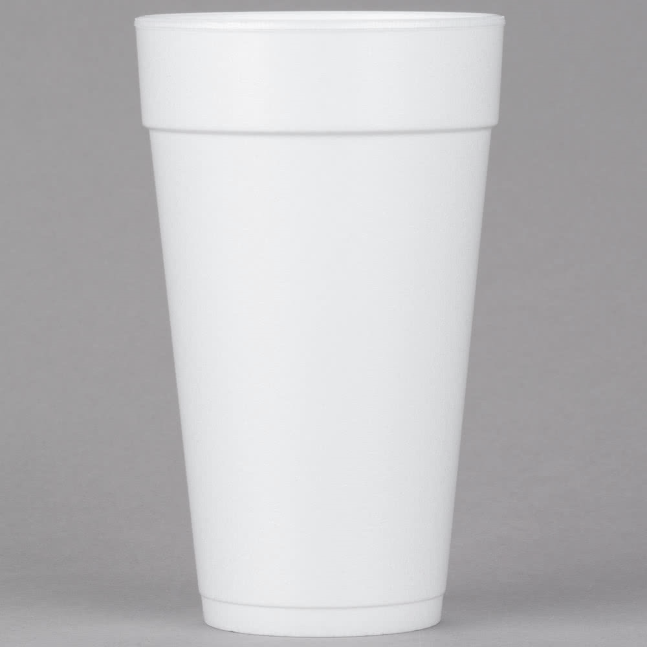

- Students will utilize the Elements of: Shape, Form and Space to create a successful 3-dimensional sculpture.
Visual Design and Production C.12.1

- Students will deconstruct the cup shape and reconstruct it in a way that does not resemble the original shape.
Visual Design and Production C.12.4

- Students will problem solve creative connection solutions. Visual Design & Production C.12.7

- Students will finish the sculpture using high quality craftsmanship.
Visual Design and Production C.12.8

